



ML Ops & Containerization
LAB MANUAL

Disclaimer: The content is curated from online/offline resources and used for educational purpose only
GitHub Collaboration Using Pull Requests – Event Registration System
Objective
To understand collaborative software development using GitHub by creating feature branches, submitting Pull Requests, reviewing changes, and merging code.
Problem Statement
A software company is developing an Event Registration System. Multiple developers contribute to different modules. Before merging new code into the main project, every change must be reviewed through a Pull Request.
Requirements
Software
- Git
- GitHub
- VS Code
Files
- README.md
- registration.py

Procedure
Step 1: Fork or Clone Repository
git clone https://github.com/ramar92/EventRegistration.git
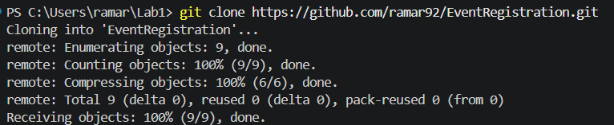
Step 2: Create New Branch
git checkout -b feature-email

Step 3: Modify registration.py
print("Event Registration System")

name = input("Enter Name: ")
email = input("Enter Email: ")
phone = input("Enter Phone: ")

print("\nRegistration Successful!")
print("Thank you,", name)
print("Email:", email)
print("Phone:", phone)

Updated the code with phone number

Step 4: Commit Changes
git add .
git commit -m "Added phone number registration"
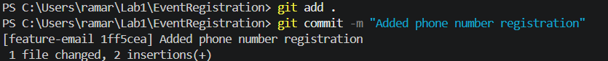
Step 5: Push Feature Branch
git push origin feature-phone
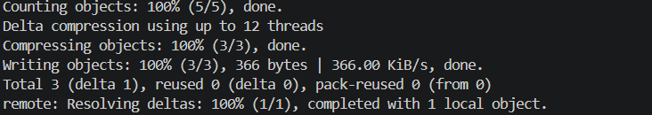
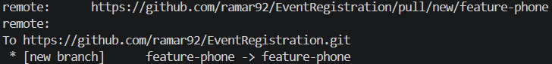
Step 6: Create Pull Request
- Open GitHub.
- Navigate to the repository.
- Click Compare & Pull Request.
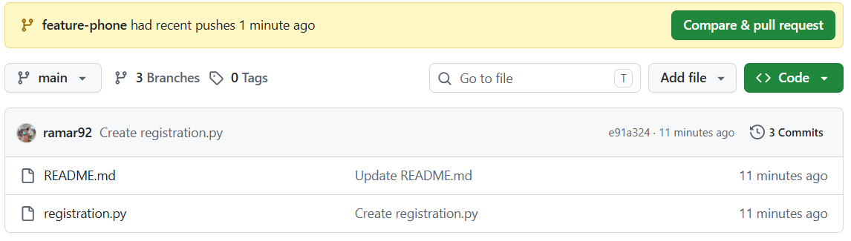
- Review the changes.
- Add a meaningful title and description.
- Click Create Pull Request.
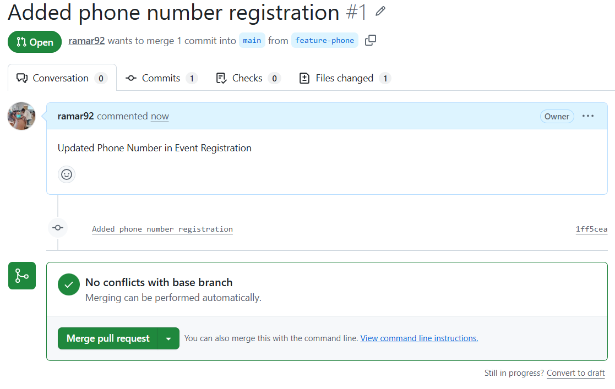
Step 7: Review Pull Request
- Review the changed files.
- Add comments if required.
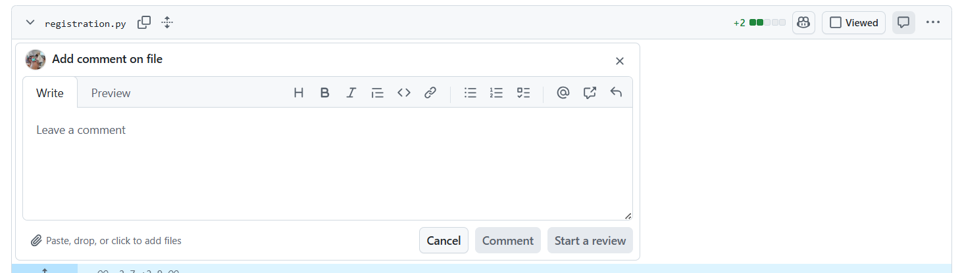
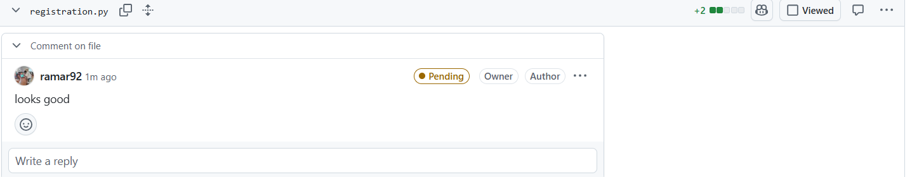
- Approve the Pull Request.
Step 8: Merge Pull Request
Click:
Merge Pull Request

Then
Confirm Merge
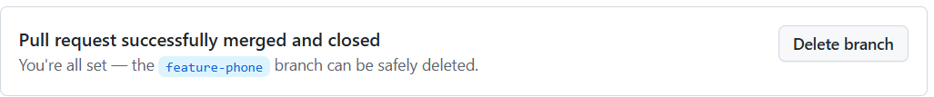

Step 9: Update Local Repository
git checkout main
git pull origin main
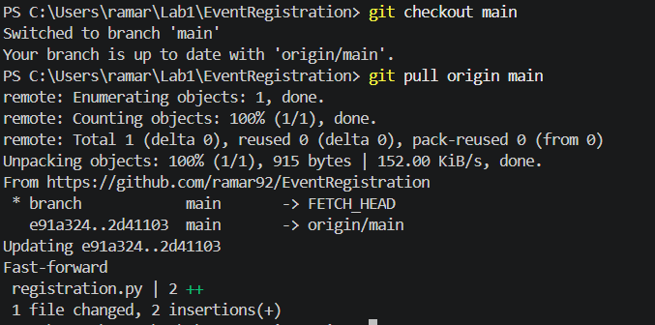
Conclusion
Students learned how GitHub facilitates collaborative software development through feature branches, Pull Requests, code reviews, and merging. This workflow mirrors real-world software and machine learning team practices, ensuring organized development, effective collaboration, and high-quality code integration.

